Educate! 3 Year Strategic Plan

2019-2021

Updated March 2019

Purpose/Vision/Why We Exist
Prepare youth in Africa with the skills to succeed in today’s economy.

Mission
Develop young leaders and entrepreneurs in Africa.

What We Do
Educate! prepares youth in Africa with the skills to succeed in today’s economy.
We tackle youth unemployment by reforming what schools teach and how they teach it, so that youth in Africa have the skills to start businesses, get a job and drive development in their communities.

Cultural Tenets: How We Behave
- Youth First – We design and manage the organization to ensure every dollar creates experiences that youth value
- Exceed Expectations – We consistently do more than what is asked to achieve the best results possible and invest in developing our team to ensure we realize our individual and collective potential.

- Always Learning – We are committed to seeking and applying new knowledge and ideas through research, books and people, as well as through trying new approaches.
- Flexible and Open Minded – We are excited by new responsibilities, listen to others/feedback, and change plans when needed

- Only Solve a Problem Once – We proactively solve and communicate problems, build systems, and create long-term solutions

Vision
Educate!'s Vision is to measurably impact millions of youth across Africa each year.
Note: This vision is aspirational and meant to serve as Educate!’s North Star – where we want to get to. Success for us is based on progress towards the vision rather than getting to one specific number of students.

Organization Development Goals: Strategic Anchors
Educate! is an non-profit social enterprise grounded in the following strategic anchors (in order of priority), which should drive annual goal setting across multiple countries.
- Impact: Commitment to create visible, measurable change in students’ self-initiated actions and livelihoods. (Core activities: quality program implementation and impact evaluation research).
- Scale: Design replicable, relevant and easily distributable program model. (Core activities: growth and expansion).
- Education Reform & System Change: Invest in national ecosystem to promote education system delivering impact on Educate!’s target outcomes. (Core activities: technical advisory and government partnerships).
- Sustainability: Strategic philanthropy funding partners fund program model development and general R&D. (Core activities: design and revenue generation).
- Learning: Continuously improve through build-measure-learn loops, informed by monitoring and evaluation, beneficiary/stakeholder feedback, leading organizations and research. (Core activities: pilots, experiments, BMLs).

3 Horizons Program Strategy Model

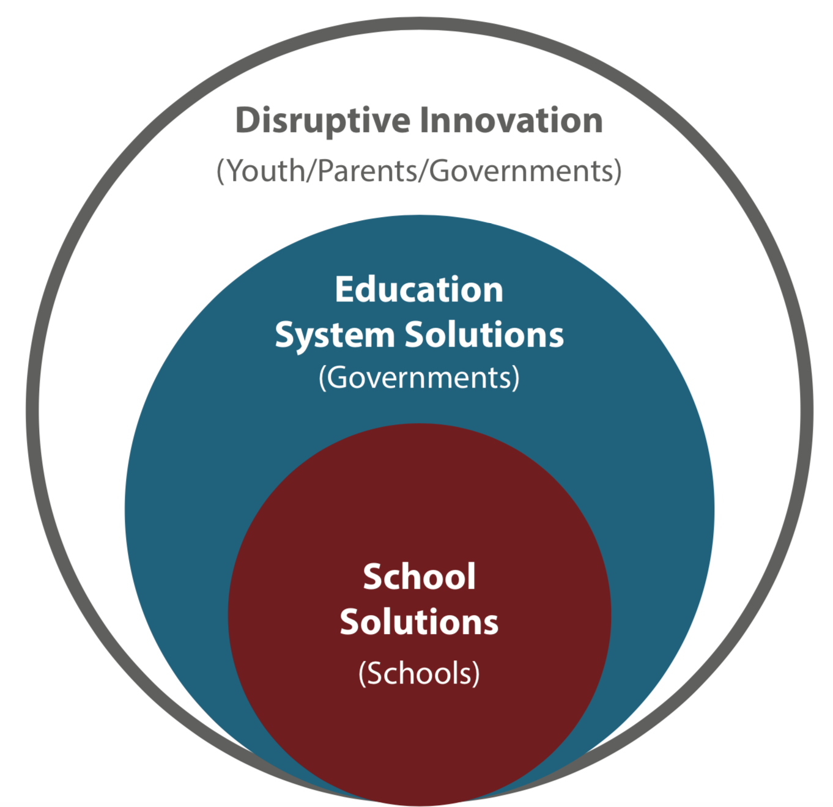

3 Year Implementation Plan

Educate!’s goal by end of 2021 is to:
- Uganda: Expand to 1,000 schools by 2021, drive towards financial sustainability and becoming fully a social enterprise.

- Rwanda: Iterate on our education system support program with new batch of schools, starting mid 2018. We will also remain open to strategic education system support opportunities that are in line with E! long term vision.

- Kenya: Test “Disruptive Innovations” solution that impacts out-of-school youth in a financially sustainable way.

Revenue/Fundraising Strategy
Educate!’s core revenue strategy for direct-to school programs and education reform innovation focuses on building strong, long-term relationships with impact-oriented strategic philanthropy partners. Educate! also aims to sell its education reform services to governments, big private philanthropy, and bilateral/multilateral funders.

What We Are
Educate! is a non-profit social enterprise. This means that while we do aim to be as financially sustainable as possible, we are not profit seeking and prioritize impact first.

